2021 NoOneFightsAlone TOURNAMENT SHIRT PRE ORDERS
There will be limited amount at the tournament
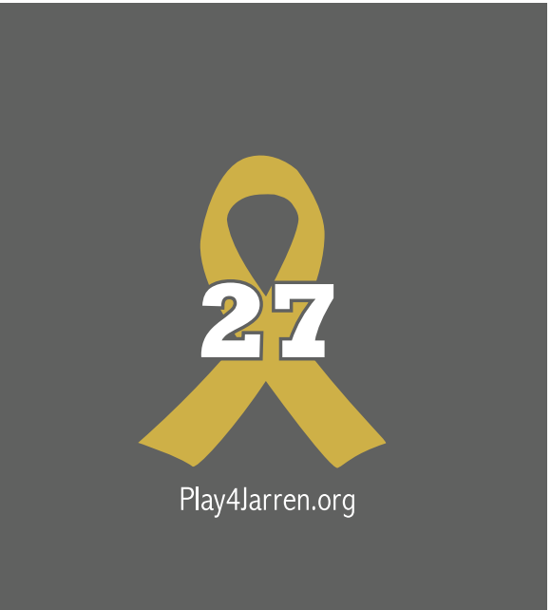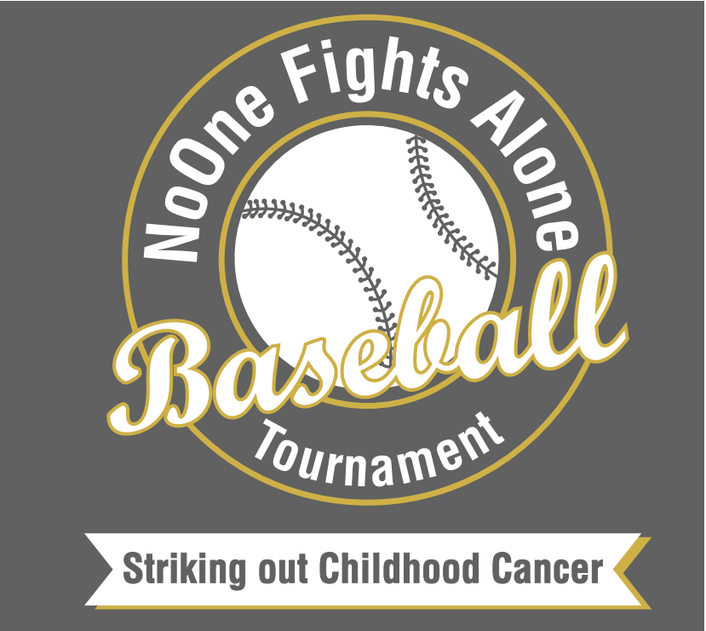

NAME:_________________________________________________________________
TEAM NAME:____________________________________________________________
$15.00 - 50/50 Cotton Shirts
Youth S | Youth M | Youth L | Youth XL | Adult Small | Adult Med | Adult Large | Adult XL | Adult XXL
$20.00 – Dry Fit (only available on pre-order)
Youth S | Youth M | Youth L | Youth XL | Adult Small | Adult Med | Adult Large | Adult XL | Adult XXL
TOTAL DUE: ___________________________________________
ORDER DUE DATE: Wednesday Sept 22, 2021
You can order online at Play4Jarren.org or Send orders to: Kimcharlton1@hotmail.com

